# Git Insights

จำนวน 1 Repos (แก้ไขจำนวน repo ตามจริง)

## Repo 1

### Commits

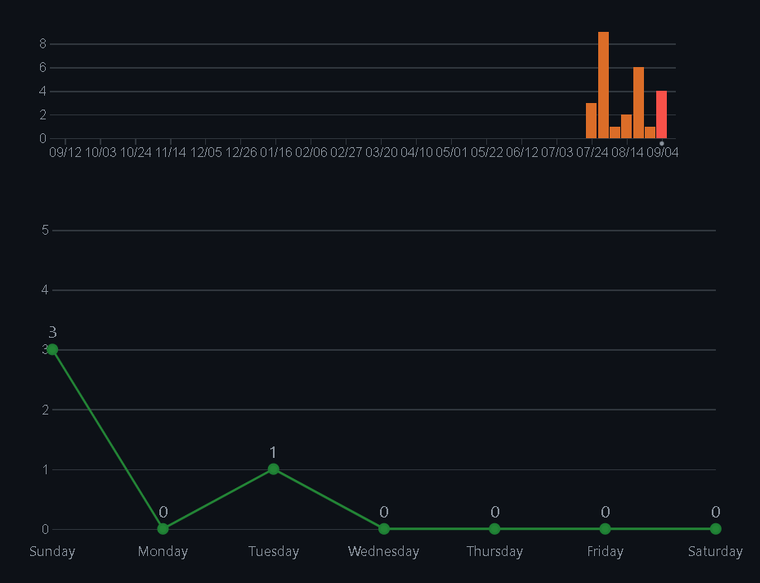https://github.com/SarayutPech/Kmitl_project_Rouge_Like_Action-RPG/graphs/commit-activity

### Contributors

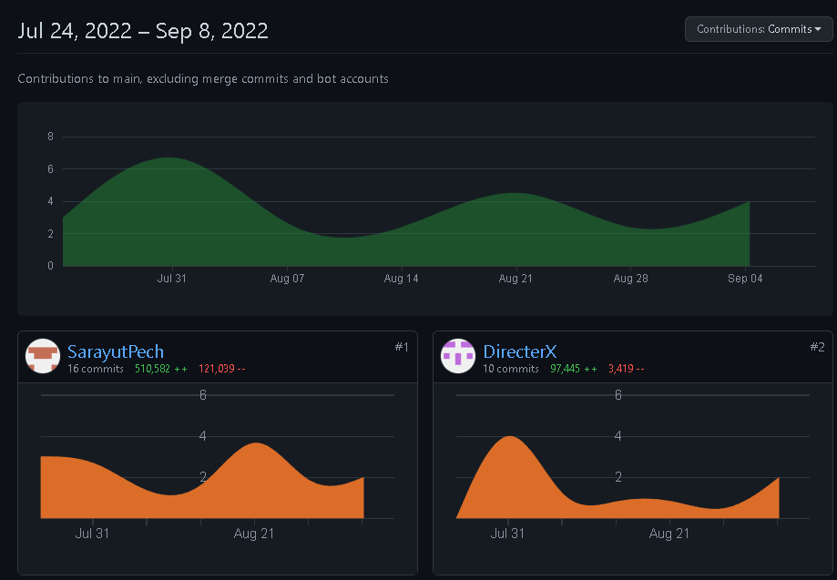https://github.com/SarayutPech/Kmitl_project_Rouge_Like_Action-RPG/graphs/contributors

### Commit Messages

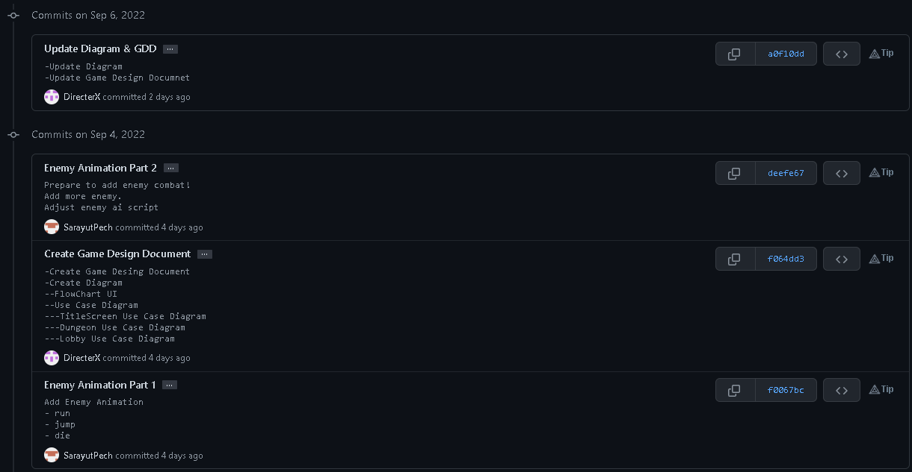

Branch

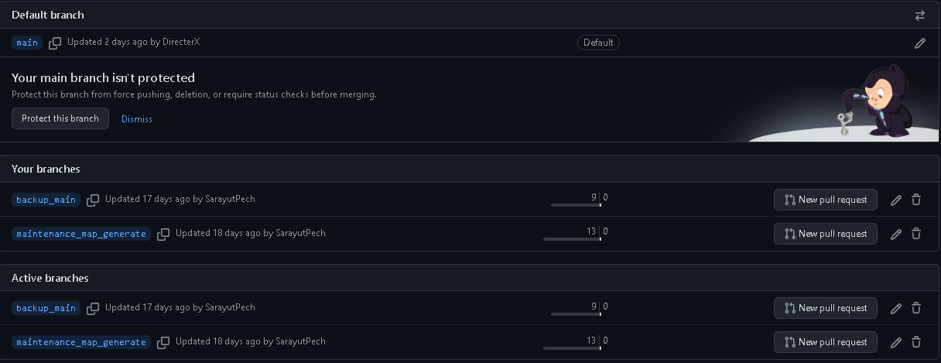https://github.com/SarayutPech/Kmitl_project_Rouge_Like_Action-RPG/branches